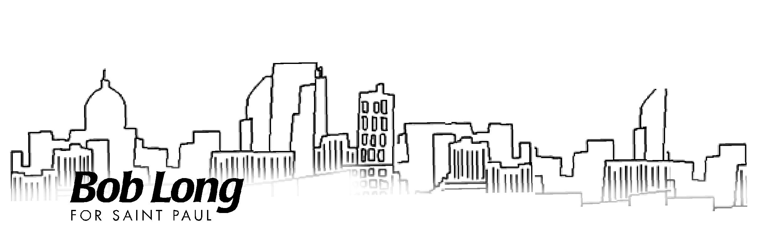
Saint Paul Progress 2005:
A Blueprint to Keep Saint Paul Moving Forward

The Vision For Job Creation and Economic Growth

Executive Summary

Saint Paul has enjoyed significant economic growth over the past decade, aided by a booming national economy and the leadership of Mayor Norm Coleman. The challenge for the next mayor over the next four years is to maintain this economic momentum, maintain the confidence of businesses and residents, and Keep Saint Paul Moving Forward.

Any plans to continue this economic prosperity must include maintaining and building upon the excellent partnerships within the Saint Paul business community. These partnerships have included cooperative efforts between the city and organizations including the Chamber of Commerce, Capital City Partnership, the Riverfront Corporation, and the Convention and Visitors Bureau. These partnerships have played a major role in Saint Paul’s downtown renaissance these past eight years.

As Mayor, I will use my energy, experience, and vision to lead this great city and Keep Saint Paul Moving Forward by continuing and strengthening these working relationships, as well as by focusing on:

- Workforce Readiness;
- Neighborhood Redevelopment;

High Tech & Small Business Entrepreneurial Development;
- Tourism;

Downtown & Riverfront; and

Fiscal Responsibility and Holding the Line on Property Taxes.

Workforce Readiness
The availability of a well-trained labor market is key to new job and business development. The city must become a partner with business, labor, schools and colleges through an “Urban College and University Initiative” to improve our workforce readiness. The City must also work closely with our public schools to promote readiness. The City must also work closely with our public schools to promote educational excellence. By developing a well-educated work force, Saint Paul will be able to retain and attract the best employers and have the best work force in America.

Neighborhood Re-Development

We must promote economic development throughout our culturally diverse neighborhoods. From the West Side’s Latino Marketplace to the North End, from the Asian and African-American businesses on University and Selby Avenues back to Payne-Arcade, we must work to draw people to all parts of the richly diverse tapestry that makes up Saint Paul.

To do this, we will initiate a “Neighborhood Redevelopment Corporation” that would be modeled after Saint Paul’s successful Riverfront Corporation and Lowertown Redevelopment Corporation to bring business, labor, foundation and neighborhood business associations and Community Development Corporations together. This partnership would attract millions of dollars of new private investment and focus financial resources and business development expertise on brownfield clean-up and strategic neighborhood commercial and housing and redevelopment.

High Tech & Small Business Entrepreneurial Development

We should make Saint Paul become the small business and high tech start-up center of the Midwest. The city should aggressively recruit high business by:

- Streamlining our regulatory process;

- Creating a “one stop shopping and customer friendly” approach;

- Paying attention to the needs of new immigrant business owners;

- Laying necessary high-tech infrastructure such as high-speed fiber optics along our commercial corridors;

- Reinventing PED to establish a “Neighborhood Business Entrepreneur Center;”

- Recruiting start-up companies and their CEO’s to Saint Paul to create an exciting entrepreneurial climate for emerging high tech and small businesses that will grow and expand in Saint Paul; and

- Developing an international business culture by cultivating relationships with key international businesses and their CEO’s and top technical personnel.

Tourism

We will work with the great team at the Convention and Visitors Bureau to make Saint Paul the Tourism & Visitor Capital of the Midwest. Let’s keep our current momentum going by:

- Formally establishing and marketing Saint Paul’s Downtown “Cultural and Entertainment District,” focusing on our important cultural and entertainment attractions. These include, among others, the Science Museum, the Children’s Museum, the Ordway, the Minnesota Museum of Art, the Minnesota History Center, and the Fitzgerald Theater;

- Bringing the Bell Natural History Museum to Downtown to be part of our growing “cultural district;”

- Initiating a new “Mississippi Riverfest,” a summertime festival promoting Saint Paul’s Downtown and Riverfront;

- Building the “Great Mississippi Trail” (modeled after Boston’s Freedom Trail) connecting Saint Paul’s cultural attractions, historical landmarks and historic figures with public art and public spaces along the route;

- Completing the permanent “Peanuts” sculpture and continue summertime “Peanuts on Parade” characters throughout the city;

- Bringing the Minnesota Thunder and other soccer events downtown;

- Recruiting more conventions and trade shows;

- Expanding Minnesota’s Transportation Museum in Downtown;

- Establishing Saint Paul as “Tournament Town” for amateur sporting events, working in cooperation with our many NCAA Division III colleges; and

- Marketing our ethnically diverse neighborhoods with a “Blues and Jazz District” along Selby, an “International Village” on University Avenue and “District del Sol” on the West Side.

Downtown & Riverfront

We will continue to build upon the progress in our downtown and along our magnificent Riverfront by creating more housing in downtown and along the river, bringing more businesses to downtown, strengthening retail businesses in downtown and improving transit to our downtown and throughout the city.

- Complete the Urban Villages that are being planned downtown along the river and throughout several neighborhoods and build additional mixed use housing developments to double the downtown residential population over the next five years.

- Bring more housing, entertainment, retail and businesses to downtown; and

- Work with Federal, State, and Regional transit authorities to make Saint Paul’s Union Depot the Twin Cities stop for high-speed rail between the metropolitan area and Chicago and improve transit services for Saint Paul, including LRT and expanded bus service.

- Available transportation is a crucial component of economic development. To this end, we must advocate for improved transit funding and systems that ensure Saint Paul remains competitive in this regional economy; and

- Begin the next phase of Riverfront Redevelopment on the downtown side of the river by working to relocate the U.S. Postal Service, Ramsey County’s Government Offices and the school district off of what is considered the five most prime pieces of real estate on the riverfront. Redevelopment on these sites will make way for tax-paying housing and commercial development that will pay millions of dollars in new city taxes and help revitalize downtown.

Fiscal Responsibility and Holding the Line on Property Taxes

- Maintain a fiscally responsible administration that will hold the line on property taxes and maintain a competitive tax climate to encourage continued business confidence and investment in Saint Paul;

- Work to eliminate duplication between city and county services, consolidate functions where economically feasible and end the “double taxation” of Saint Paul homeowners and businesses for certain city and county services, thereby saving millions of dollars a year for the City; and

- Form a Joint Operating Budget Commission made up of City Councilmembers and Ramsey County Commissioners to look at ways to consolidate city and county services and reduce the tax levy in Saint Paul.

Prepared and paid for by Neighbors for Long.
Job Creation and Economic Growth Policy Group
P.O. Box 40203
Saint Paul, MN 55104
(651) 645-9171
www.longforsaintpaul.com

